User Access Creation Process
Version 1.0

Table of COntents
- Document Control.....................................................
  - Version Control......................................................
  - Approval Matrix.....................................................
- Introduction..............................................................
- Process Workflow......................................................
- Process Steps..............................................................
- References..................................................................

- Document Control
  - Version Control
Version | Date Published | Author | Reason for Change

  - Approval Matrix
Version | Approver Full Name | Approver Title | Approver Date

- Introduction
The user access creation process document (this process), provides the detailed steps that an Identity and Access Management (IAM) analyst can follow to grant access to end user machines (desktop, laptops) and company email.
For requesting access to other application(s), please refer to the relevant process documents.
- Process Workflow
The following process flow diagram provides information on the sequence of steps that the various process stakeholders need to follow for successful creation of access.
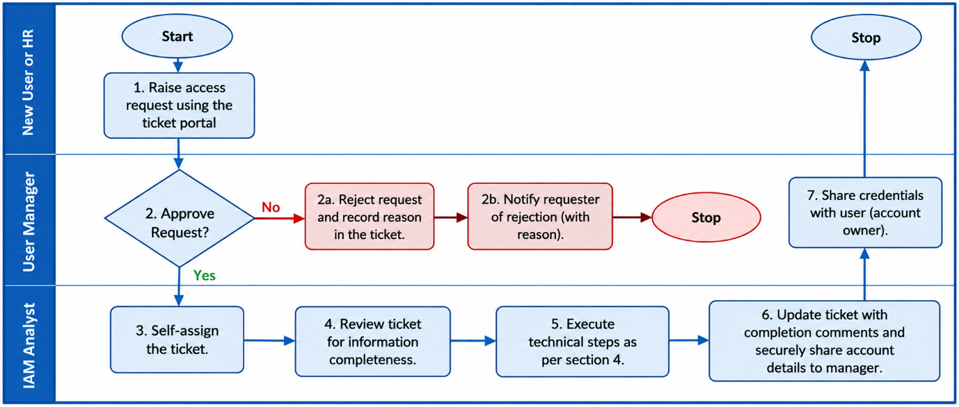
Figure 1: User Access Creation Process Flow
- Process Steps
This section provides the detailed steps to follow to progress through the process workflow.
For a new user, you will need to create a unique user account on Active Directory. Please follow the following steps to create the unique user account:
- Login to the Active Directory Server.
- Open Active Directory Users and Computers MMC from Start -> Windows Administrative Tools.
- Right-click the Organisational Unit (OU) where you want to create the new user account, select New, and then click User. Each department has a separate OU. Please note the department details from the ticket to determine the right OU.
- Fill out the following details for the user account:
    - First name: This will be the account’s first name.
    - Last name: This is the user’s last name.
    - Initials: Fill in the user’s middle initials (if any). This is optional but can be used if there are conflicts when creating the user login name
    - Full name: This will fill in automatically.
    - User logon name: This is the name used to log into the Windows domain. This will be in the format ‘firstname.lastname’
    - Click ‘Next’.
- Enter a new password and enter it again to confirm. Please select a password in line with the password security standards.
- Select “User must change password at next logon”. This will force users to change their password the first time they logon.
- This completes the steps on creating a user account in Active Directory.
- At this point, open the account and add additional information:
    - Office Address,
    - Profile path,
    - Logon script,
    - And add the user to any other Active Directory groups requested on the ticket.
- Send the credentials to the user’s manager using secure data transfer process.
- Once the credentials are sent, update the ticket with details (not credentials) and mark the ticket completed.
- References
- Password Security Standard
- Secure Data Transfer Process
- Access Management Standard
- Access Management Policy

